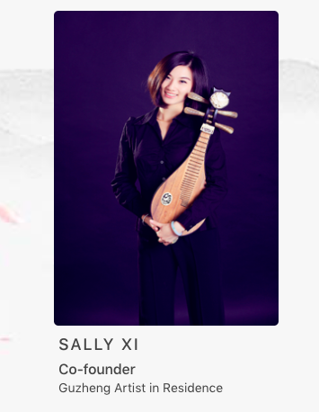1.guzheng 改成 Liuqin

2.主页轮换照片替换成这些

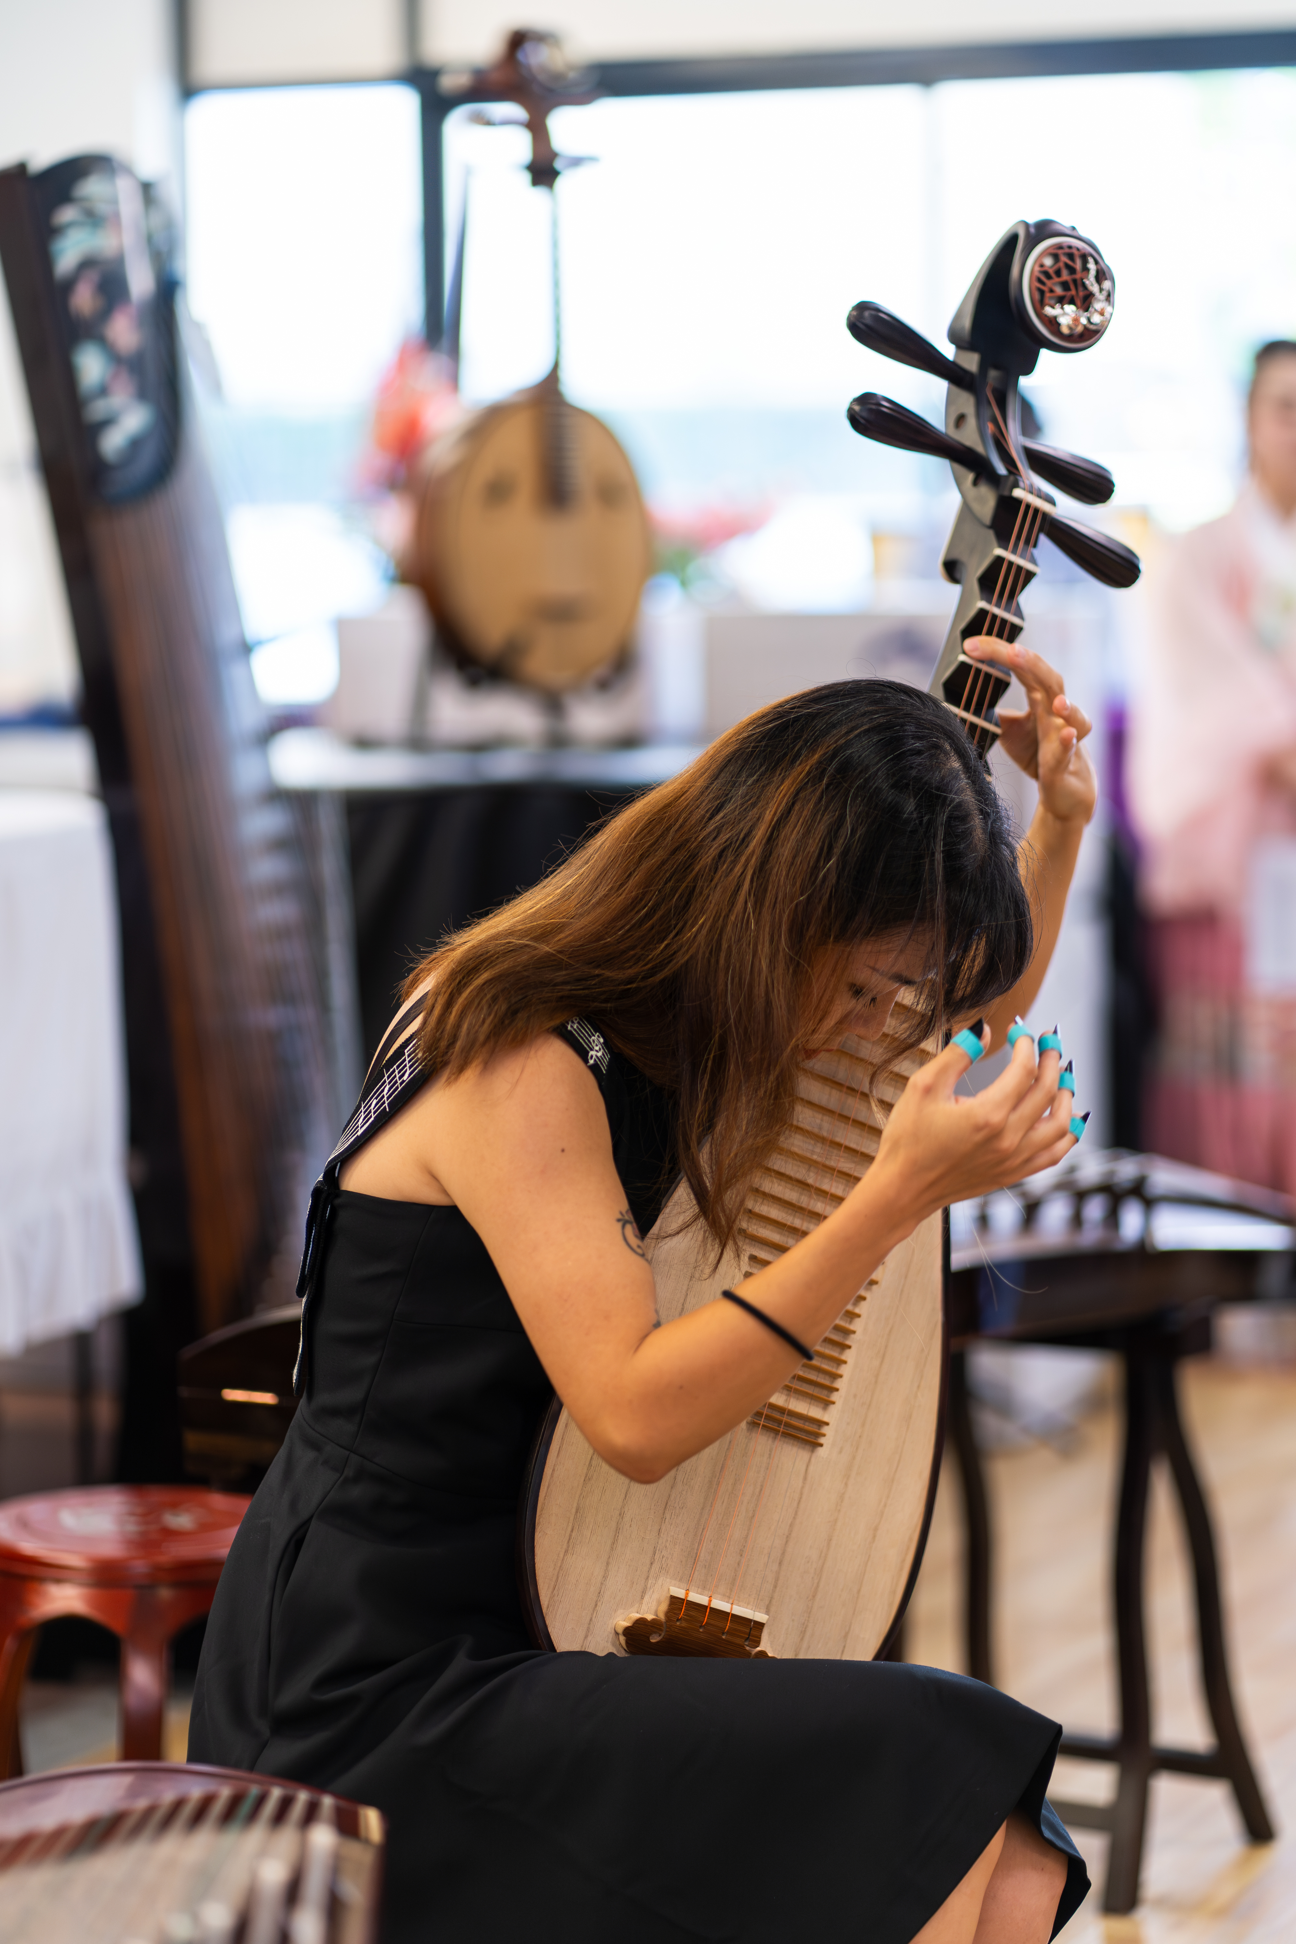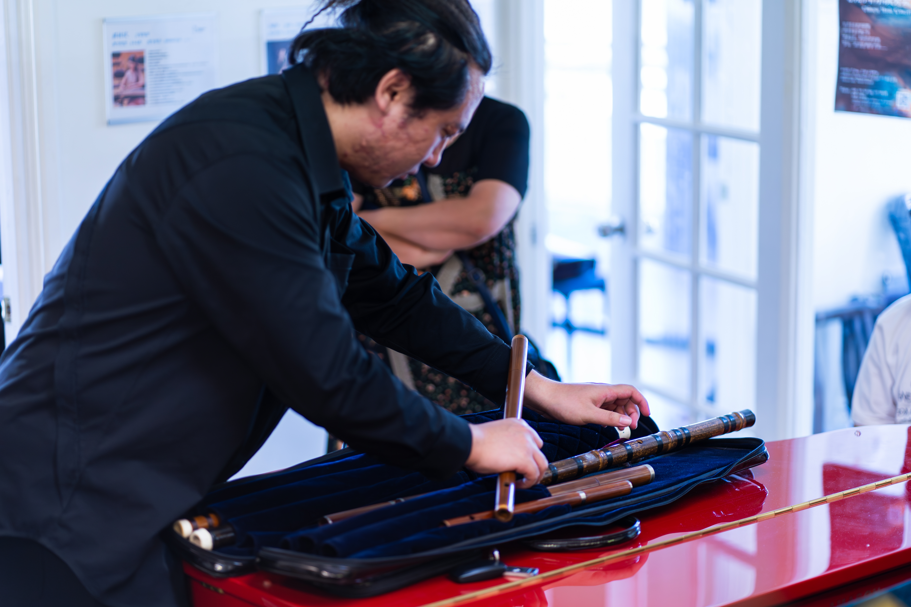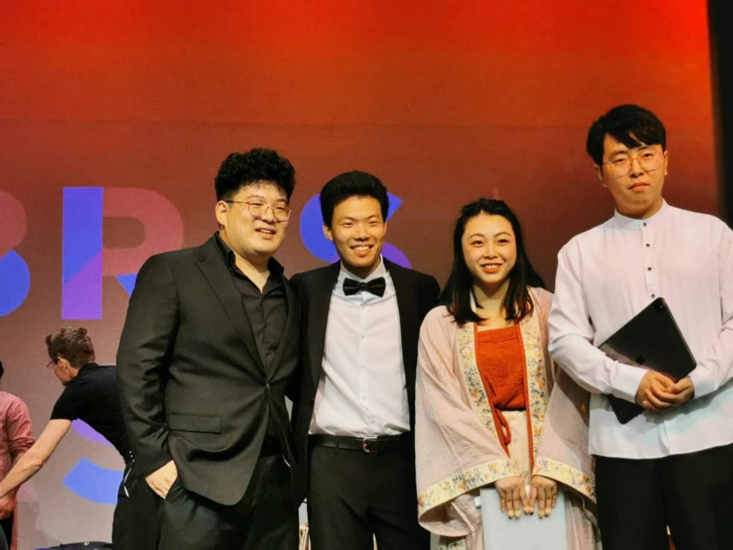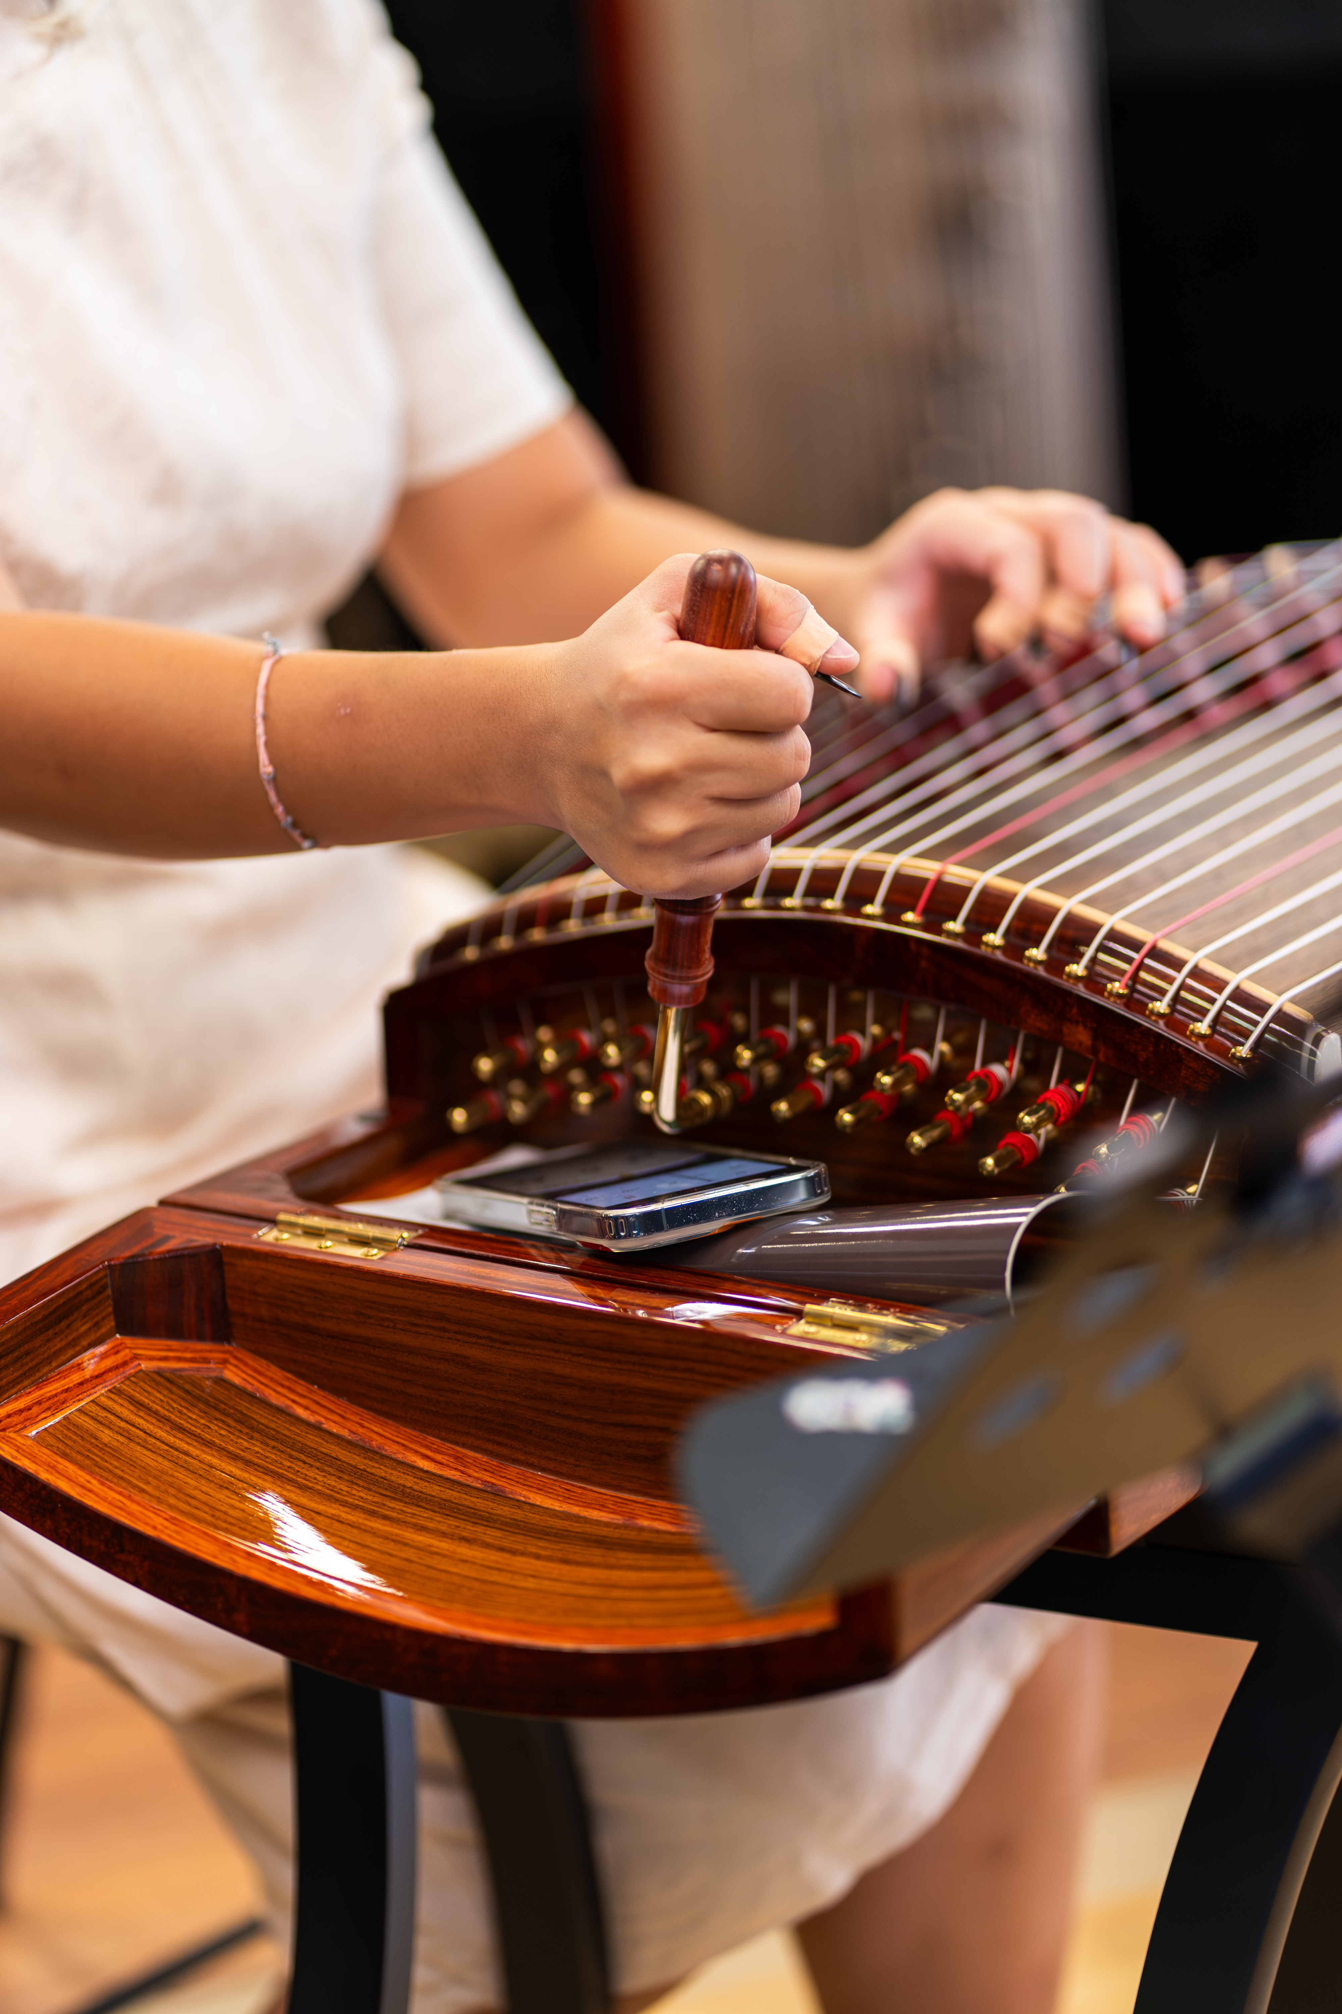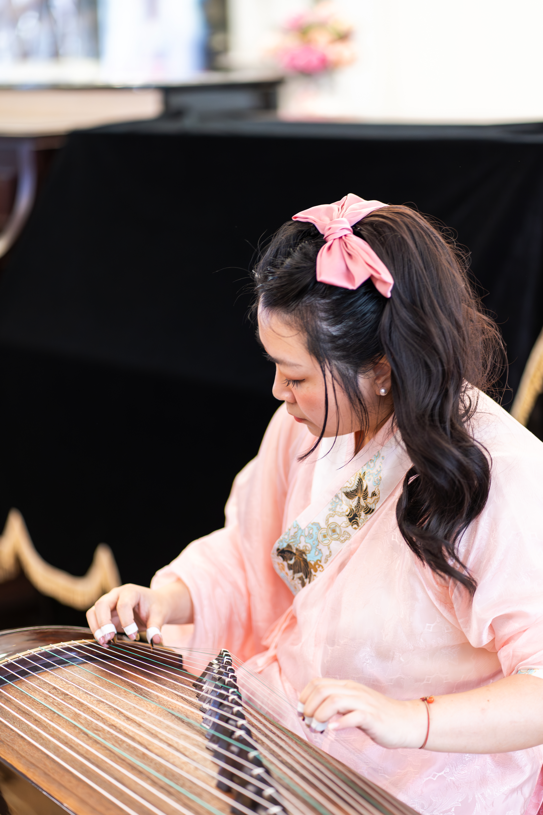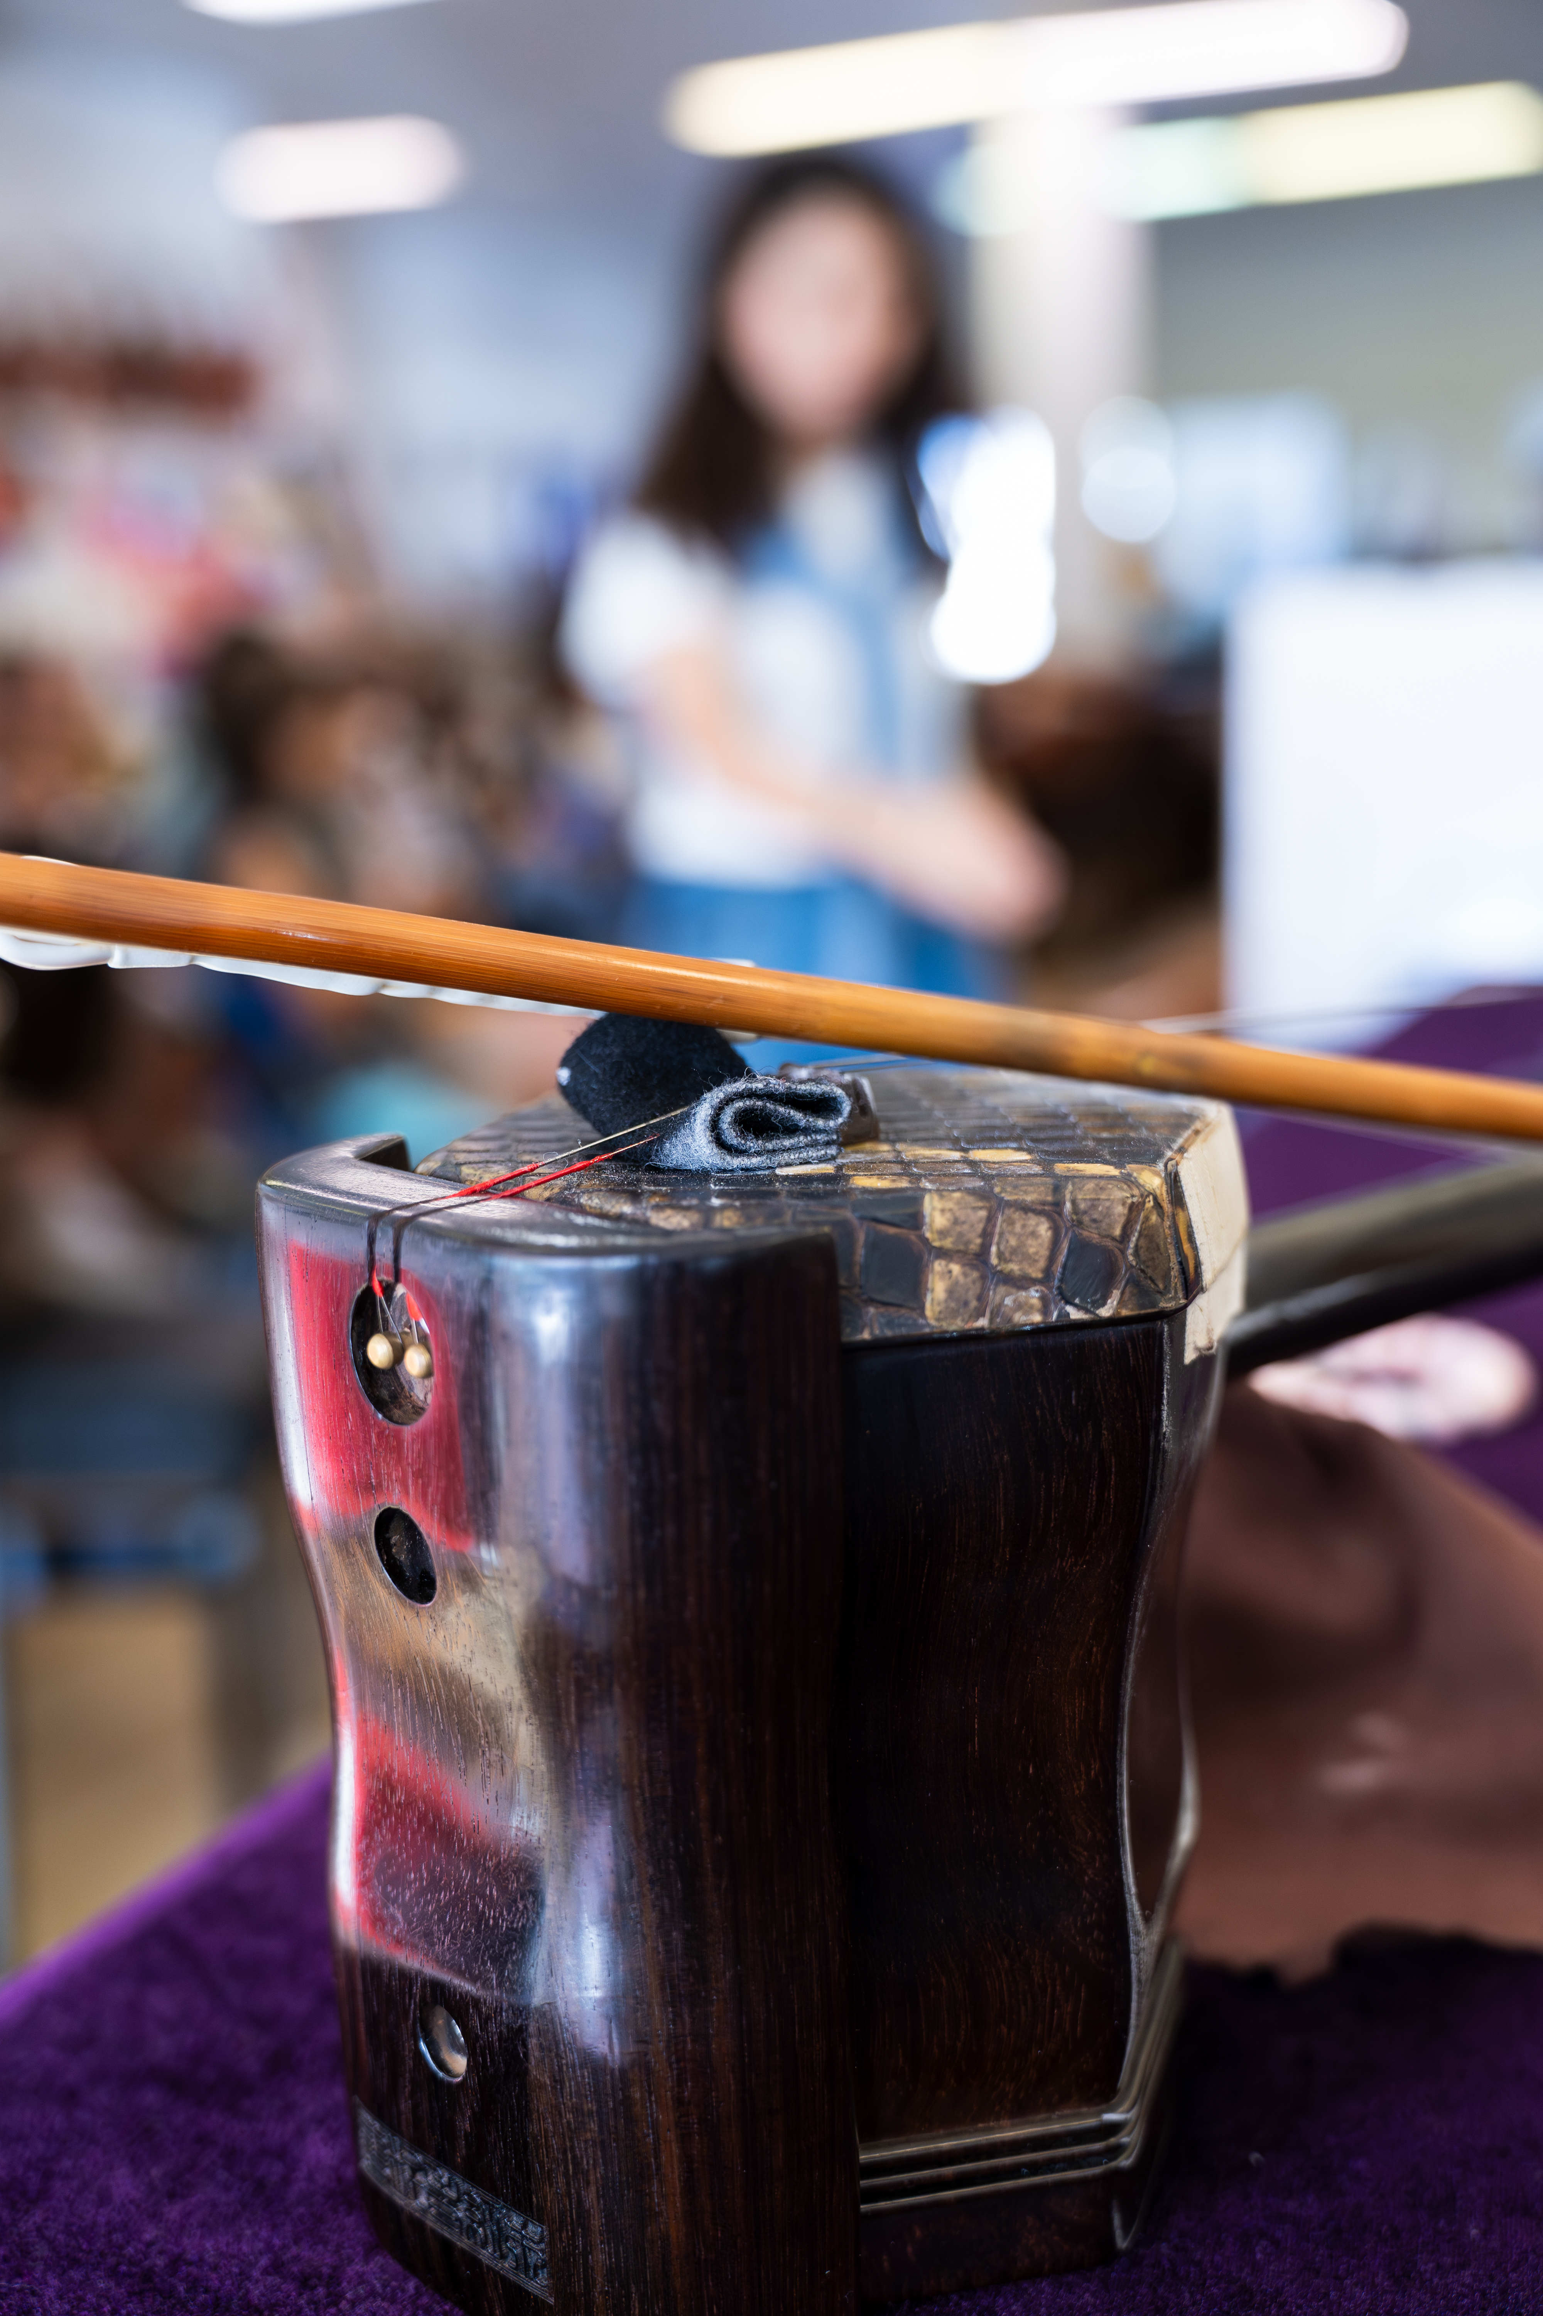

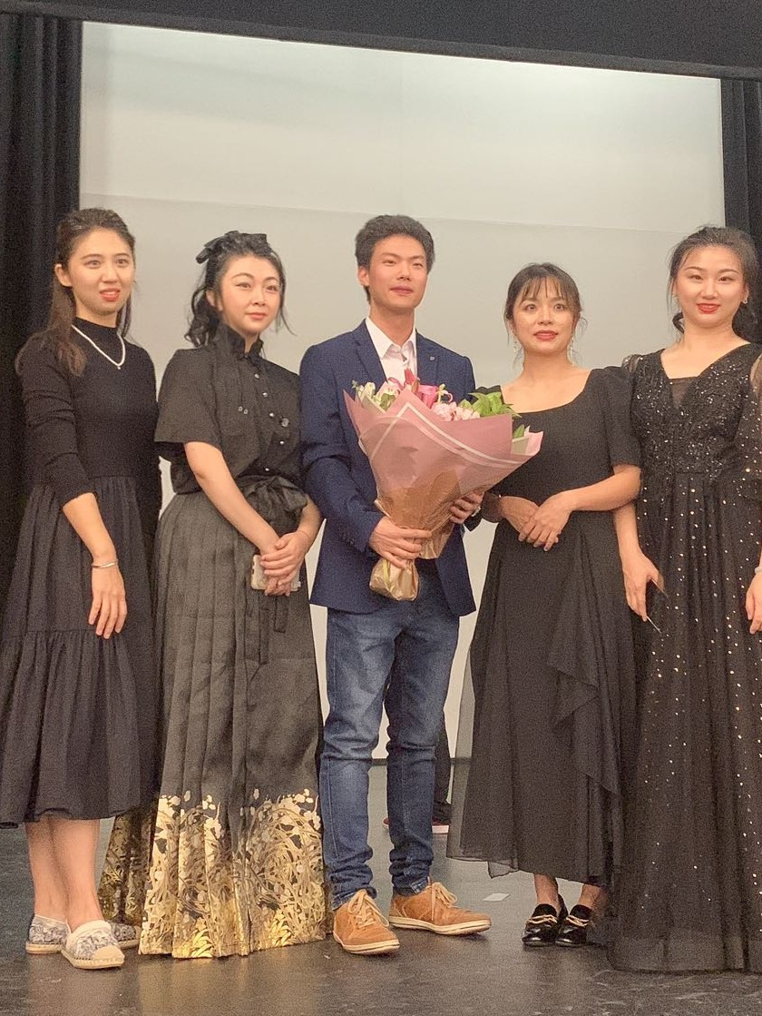

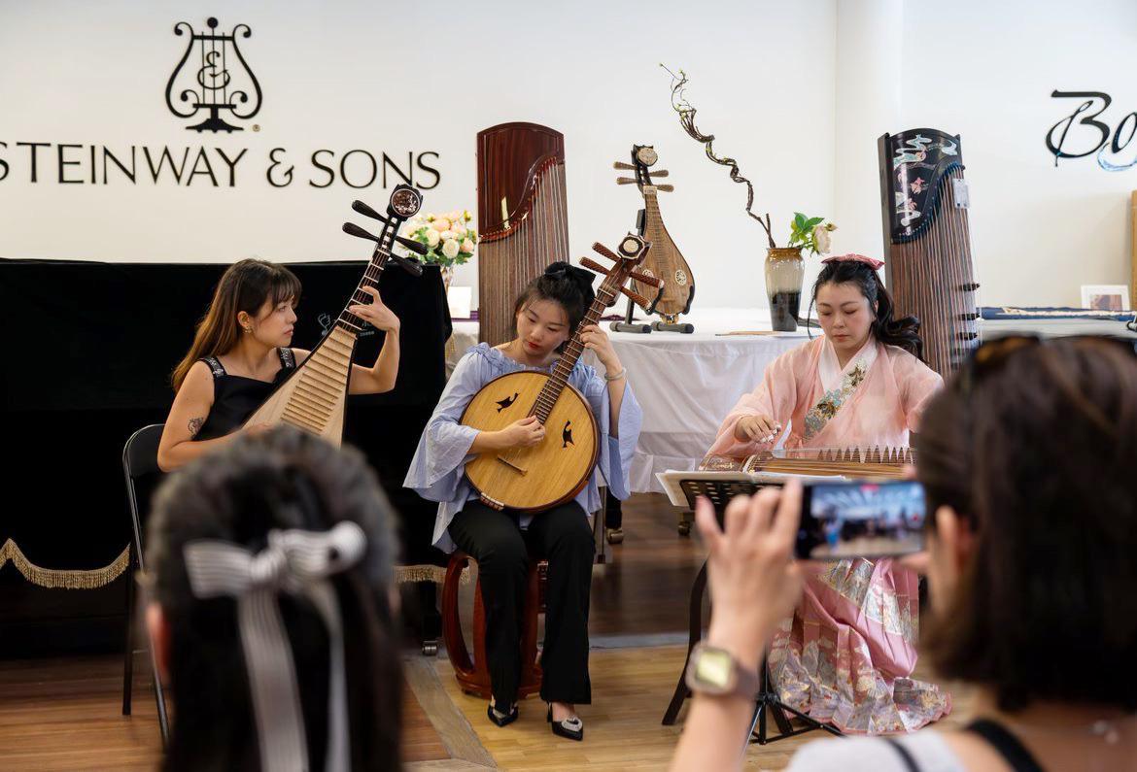

3.contact 下面加send message

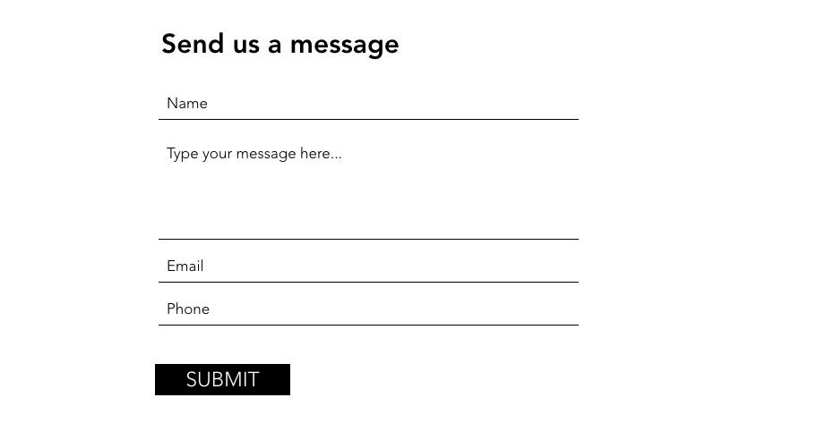

4 . Hannah 简介, 照片和bio（单独发）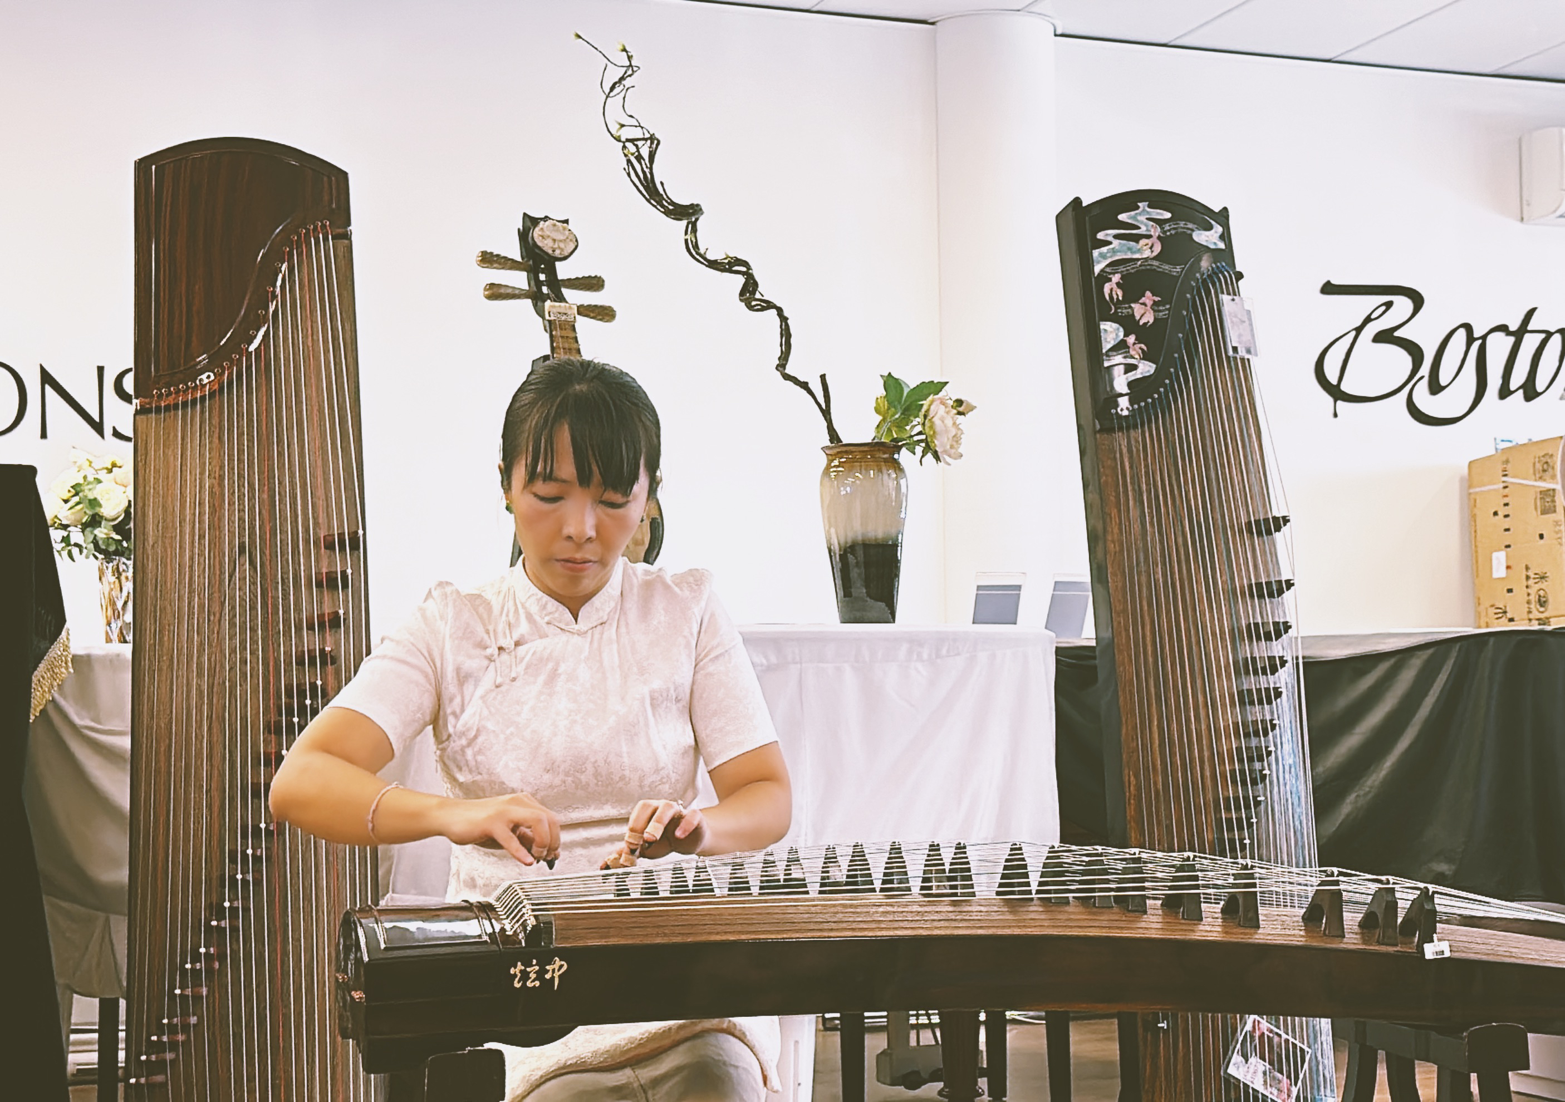

5.about us改成FEATURED ARTIST

下面加一个join us：

If you want to join us, whether teaching or performing, please submit your resume and our dedicated staff will contact you!

Send your resume：echoofjademusic@gmail.com

6. Home下面加上这段话，介绍乐团

The Echo of Jade Music Collective is a newly established Brisbane-based collective/ensemble featuring a stellar lineup of musicians consisting of some of Queensland’s best traditional instrumentalists.

All of the performers are professional musicians trained from top conservatories in China and/or abroad. Notable Australian multi-cultural concerts/productions that involved members of this ensemble include the 2022 BrisAsia Festival, the 2022 PlayLab production SlowBoat, the 2023 PlayLab production White China, and public appearances on SBS, Channel 9, ABC radio, recordings for ABC Classic etc.

7.perfomance hire

页面写上Business Performance

"If your organization or company is interested in Chinese ethnic music, Echo of Jade Music Collective can provide high-quality and professional commercial performances. Please send your information to our email address or contact us directly at 0420378345

Looking forward to collaborating with you and bringing a unique and memorable musical experience to your event.”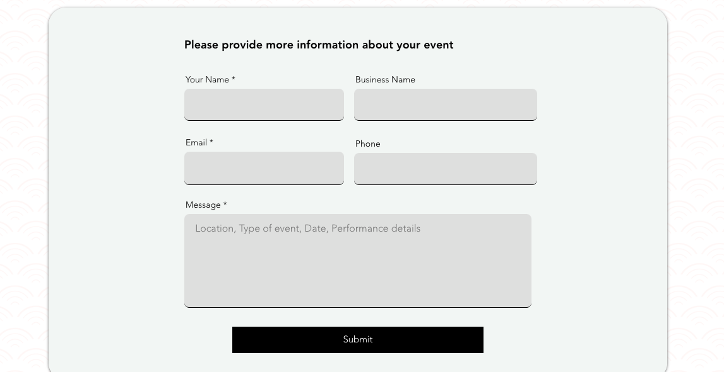

8 这里的色差是否可以调整

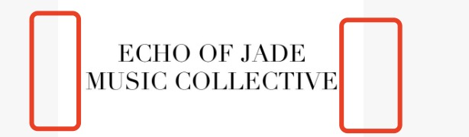

9 lesson 页面，拼写错了

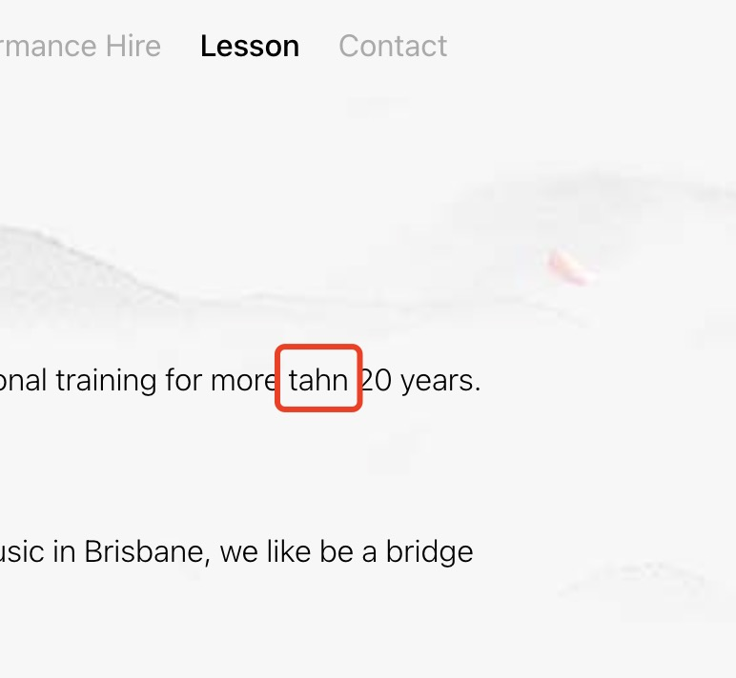

10 关于我们 中文页面‘驻场’ 删掉

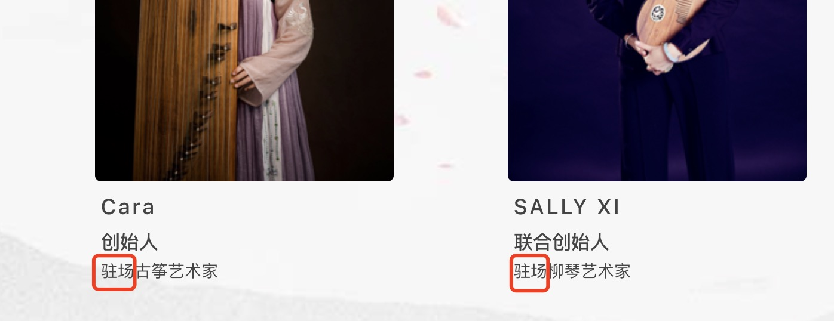

11 sally 张楚楚 陈芳慧 中文页面 主语全部删掉

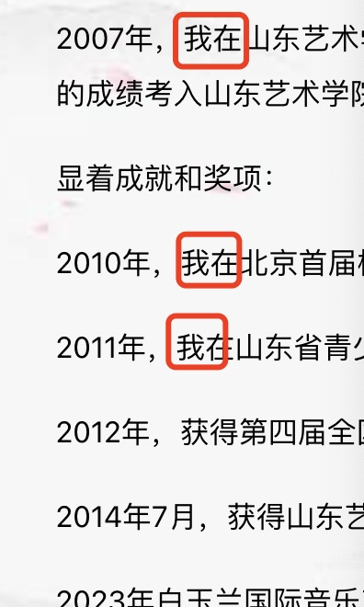

12 ray 这边 还是全部用ray lin

